ProK Buttons CAC
K4 Button K1 or K2 Buttons
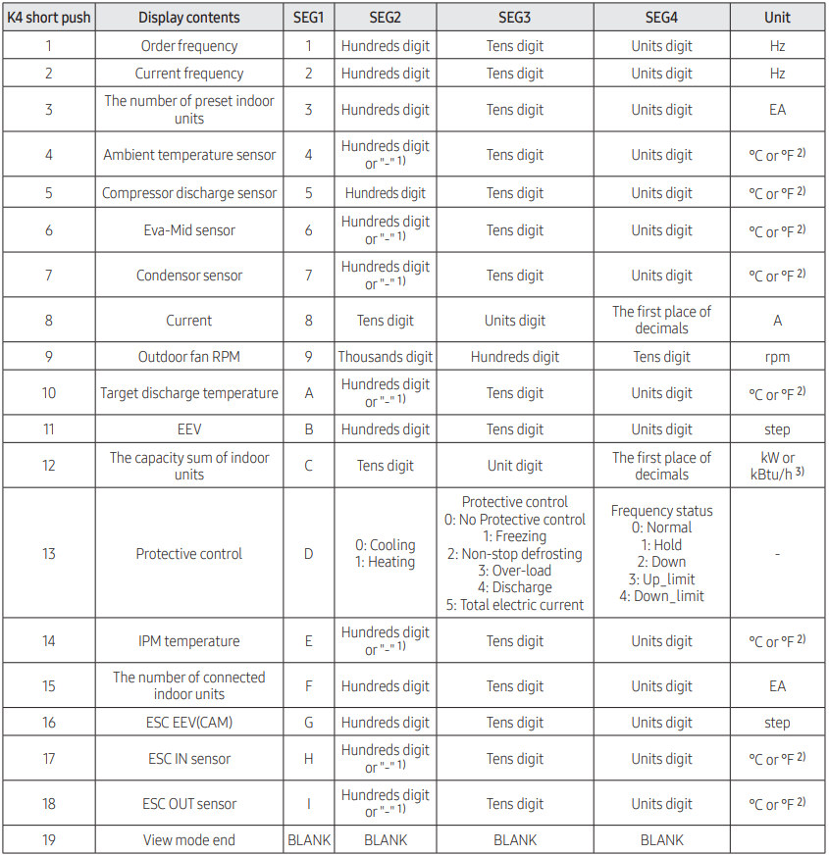
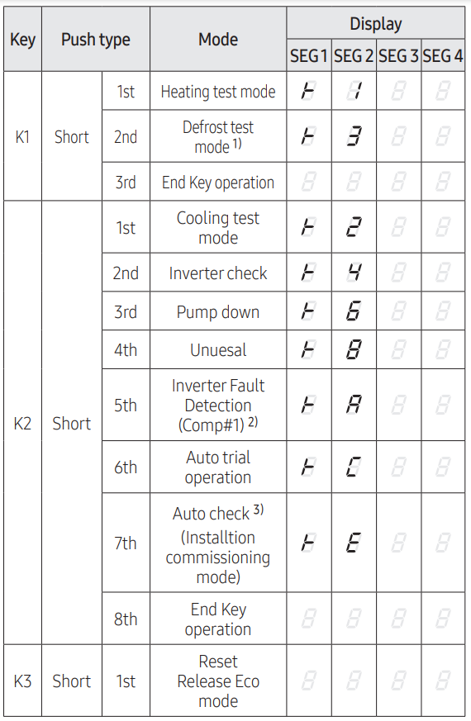

Option Setting. Press K2 for 2 seconds to enter option setting mode. Shortly press the K1 switch to adjust the value of Seg 1, Seg 2. shortly press the K2 switch to adjust the value of Seg 3, Seg 4. press and hold the K2 switch for 2 seconds to save the setting.
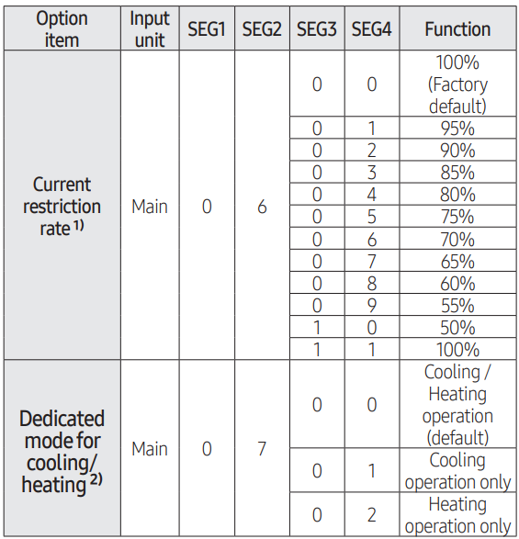
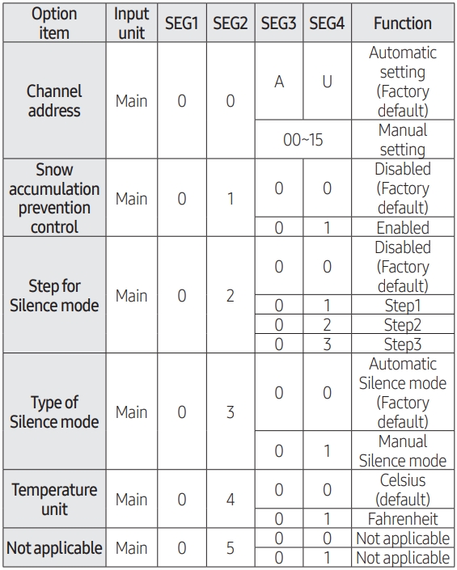

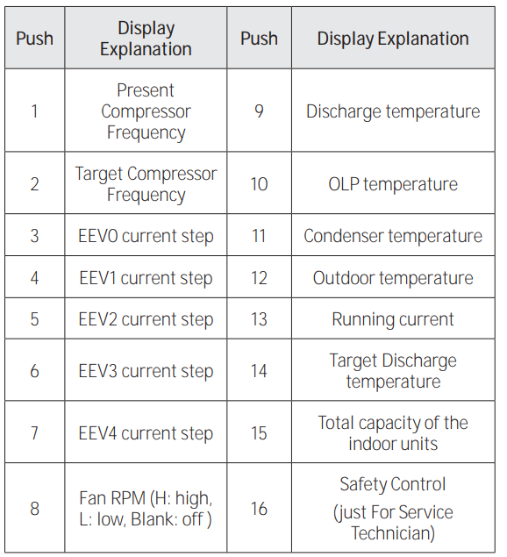
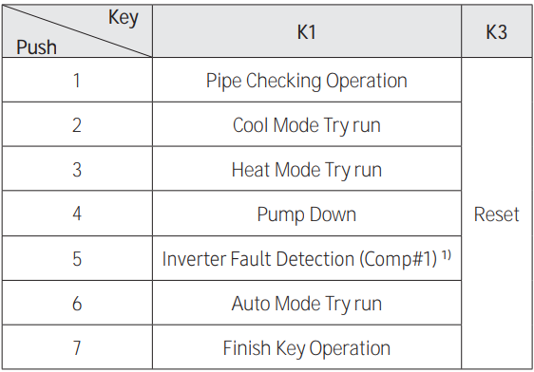
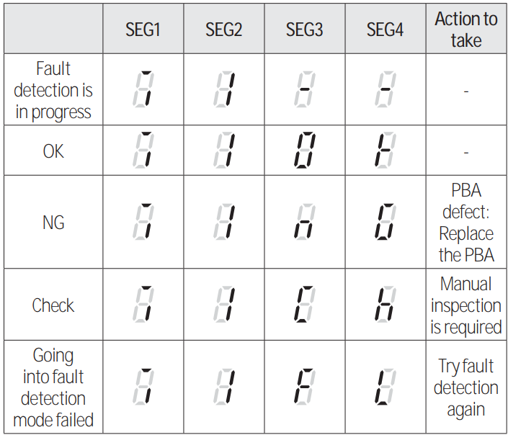
K Buttons FJM

K1 or K2 K4

10 - A
11 - B
12 - C
13- D
Inverter Check Display

14 - E
15 - F

16 - G
Celsius to Fahrenheit conversion: F = C x 1.8 + 32
KW to KBTU/hr: Btu/hr = KW x 34122.142

Protection Mode
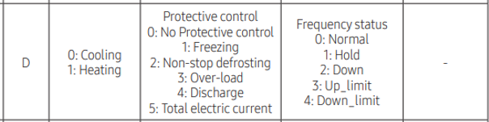
16 - G

DVM S

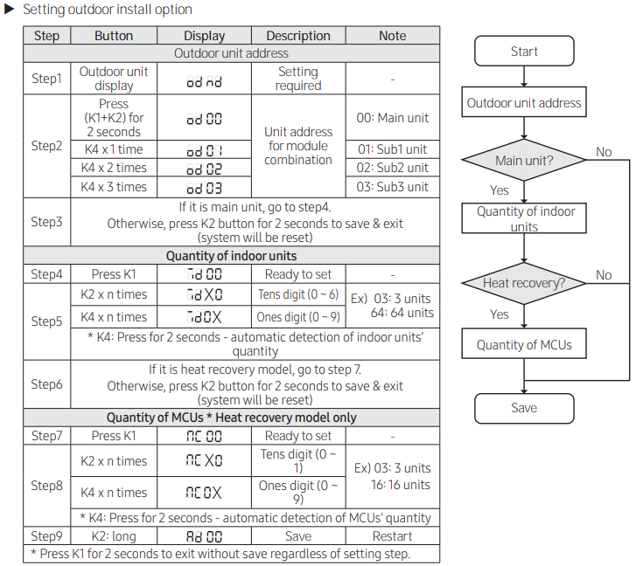
Initial Settings

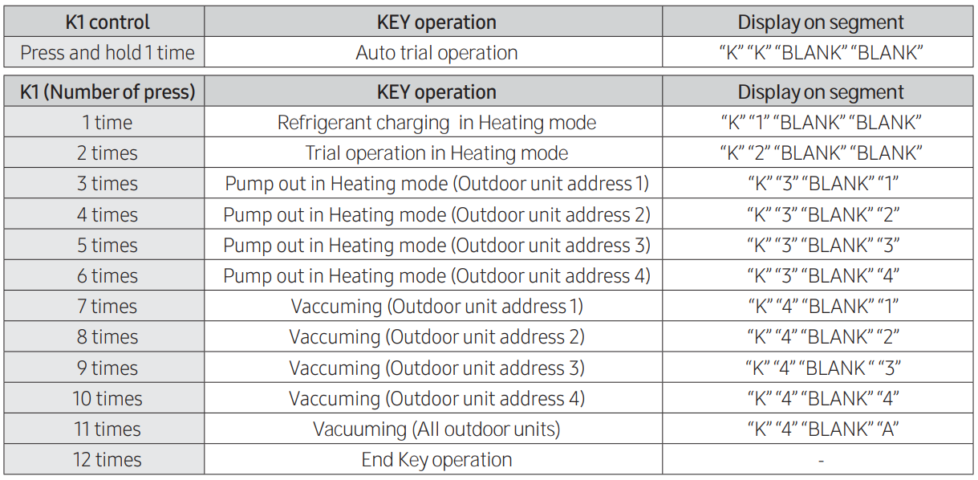
K1 Buttons

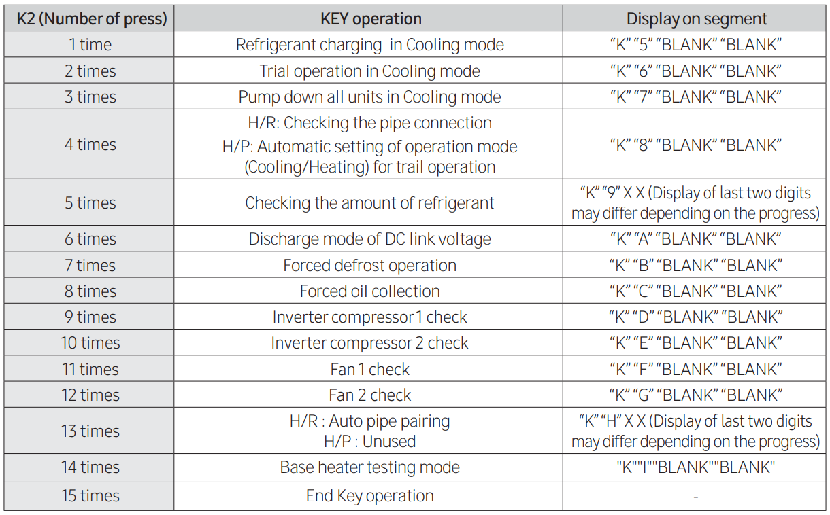
K 2 Buttons

K 4 Buttons
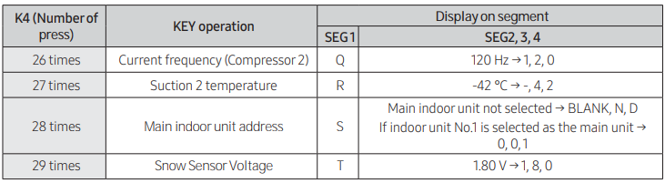
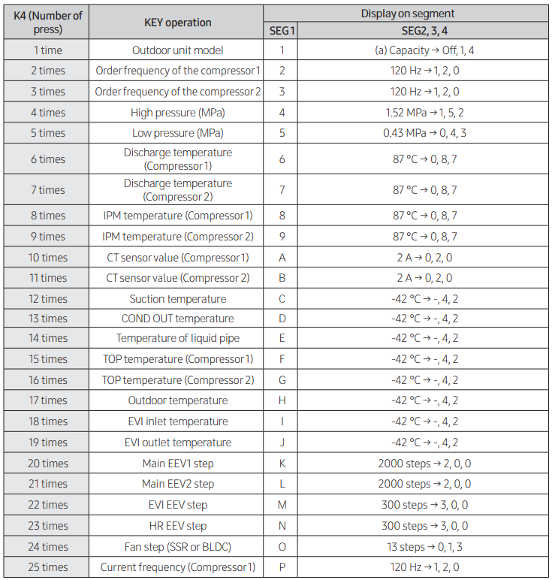
MPA to PSIG: PSIG = MPA X 145.038
Celsius to Fahrenheit conversion: F = C x 1.8 + 32
KW to KBTU/hr: Btu/hr = KW x 34122.142

